**Program Control using PConLan Protocols**

The PConLan protocols is a type of ASCII text based protocol that can be used to operate EyeVision remotely.

A control telegram always consists of a start character (“*#*”), a command number of 3 characters, an optional data array of maximum 200 characters and is terminated by a terminator (“*#*”).

For commands that return an acknowledgement, an “*OK*” is returned if the telegram is parsed by the camera, while a “*NOK*” is returned if the telegram is in the correct format but the command code/name or the parameter name/type is incorrect.

**Important PConLan Protocols**

The following protocols are only a part of the PConLan protocols available for EyeVision which are essential during the development of the web-based GUI. For the complete list of PConLan protocols, please refer to the “*SmartBuilder Program Control by LAN*” pdf or the EVT documentation wiki (*http://www.evt-web.com/wiki/doku.php?id=en:start*).

|  |  |
| --- | --- |
| 001 – Check program change | |
| Telegram: | #001<programname># |
|  | <programname>: Complete name of the check program  (Specification of the file extension “*.ckp*” is compulsory.) |
| Function: | The check program in the telegram will be loaded as the active check program. |

|  |  |
| --- | --- |
| 002 – Operation mode – “Start” | |
| Telegram: | #002# |
| Function: | The active check program will be started immediately. It will stay active even if no program is loaded or no readable program is created. |

|  |  |
| --- | --- |
| 004 – Operation mode – “Stop immediately” | |
| Telegram: | #004# |
| Function: | The active check program and all running operations will be stopped immediately. It will continue to stay stopped, even after switching to a new program, until the operation mode “Start” is executed. |

|  |  |
| --- | --- |
| 021 – Command – “SetParameter for command with command name” | |
| Telegram: | #021;<CmdName>;<ParType>;<ParName>;<Value># |
|  | <CmdName>: Command name in the comment column of the command |
|  | <ParType>: Type of parameters – 0 = String, 1 = Double, 2 = Long  (For “Enum” type, please check the library file of the command plugin to determine the actual parameter type.) |
|  | <ParName>: Name of the parameters |
|  | <Value>: Value to be set |
| Function: | The parameter of the command will be set with the value specified in the telegram. |

|  |  |
| --- | --- |
| 023 – Command – “GetParameter for command with command name” | |
| Telegram: | #023;<CmdName>;<ParType>;<ParName># |
|  | <CmdName>: Command name in the comment column of the command |
|  | <ParType>: Type of parameters – 0 = String, 1 = Double, 2 = Long  (For “Enum” type, please check the library file of the command plugin to determine the actual parameter type.) |
|  | <ParName>: Name of the parameters |
| Function: | The value of the parameter of the command will be retrieved. |

**Testing of PConLan Protocols**

For the following testing programs, the Python programming language will be used. The command will be sent to the EyeVision system through the UDP transport layer and a reply will be sent back to indicate if the command was accepted.

**Remote Starting/Stopping of the Check Program**

The following program can be executed to start or stop a check program remotely.

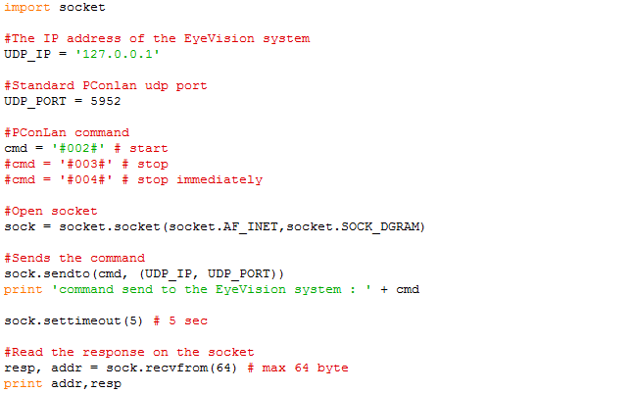

**Remote Changing of Parameters of a Command in a Check Program**

The following program can be executed to change the parameters of a command in a check program remotely, depending on the value of the variable cmd. The command can also be sent to any other system in the same network by changing the value of the variable “*UDP_IP*”.

To determine the command name, parameter name and parameter type, please refer to the “*Determine the Command Name, Parameter Name, and Parameter Type*” section for the instructions.

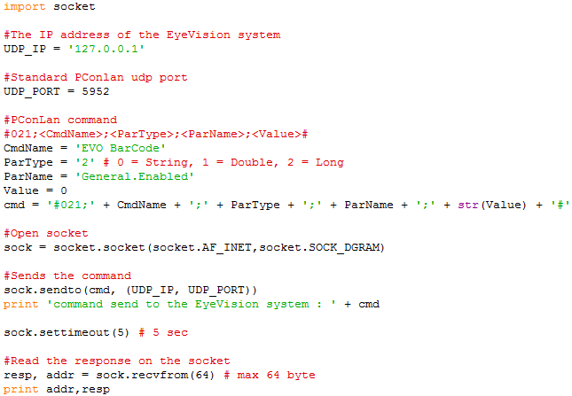

**Remote Getting of Parameter Values of a Command in a Check Program**

The following program can be executed to get the parameter values of a command in a check program remotely, depending on the value of the variable cmd.

To determine the command name, parameter name and parameter type, please refer to the “*Determine the Command Name, Parameter Name, and Parameter Type*” section for the instructions.

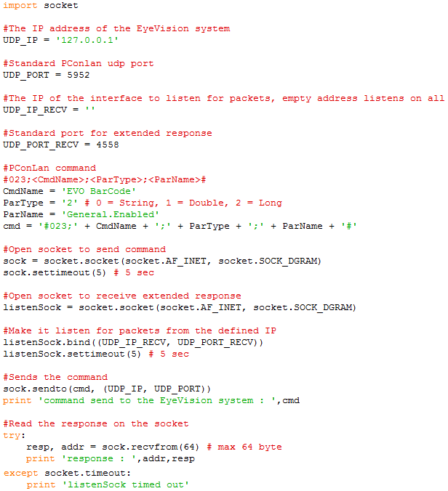

**Determine the Command Name, Parameter Name, and Parameter Type**

To determine the command name, simply look for the name listed in the comment section that is associated with the command. For example, the command name for the barcode command is “*EVO BarCode*”.

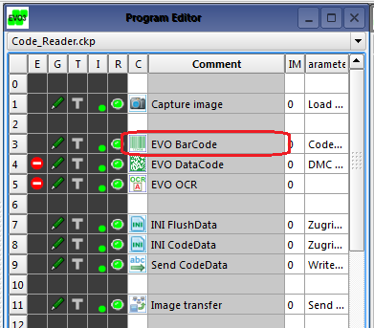

To determine the parameter name and type, simply access the list of parameters available for the command by a right click on the command icon and selecting “*Show parameter list*”.

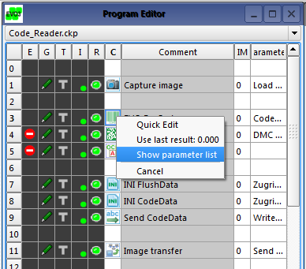

For example, the parameter name and type to enable and disable the barcode command is “*General.Enabled*” and “*Enum*” respectively.

